**Microprocessor Lab  
Lab Experiment No. 7**

Name: Ninad Rao Roll No. 53

**Aim**: Perform BCD addition of two numbers.

**Instructions on how to use TASM**:

Steps for creating the program:

1. TASM is loaded
2. TASM < Edit - We will get an edit window
3. Type the program here
4. Save the file as <filename>.asm

Steps for running the program:

1. c:\tasm> Type here tasm filename

**c:\tasm> tasm <filename>.asm**

This will save the program, and the edit window with this file name will be seen.

1. c:\tasm> Linking the program

**c:\tasm> tlink <filename>.obj**

This will create an object file after linking.

1. c:\tasm> Now to execute the program and get to the result window

**c:\tasm> td <filename>.exe**

After execution, all the window options are present to check all registers, all memory locations and so on.

**Program to perform BCD addition of two numbers**:

**Explanation**: Consider that a byte of data is present in the AL register and a second byte of data is present in the BL register. We have to add byte in AL with the byte in BL. Using add instruction, add the contents of 2 registers. Results will be stored in the AL register. Use a DAA instruction that will check if BCD is valid, if it is not valid then 6 is added to give a proper BCD result.

**Algorithm**:

**Step I:** Initialize the data memory.

**Step II:** Get the first BCD number in AL.

**Step III:** Get the second BCD number in BL.

**Step IV:** Add the two BCD numbers.

**Step V:** Using DAA, adjust result to valid BCD number.

**Step VI:** Display the result.

**Step VII:** Stop.

**Flowchart**:

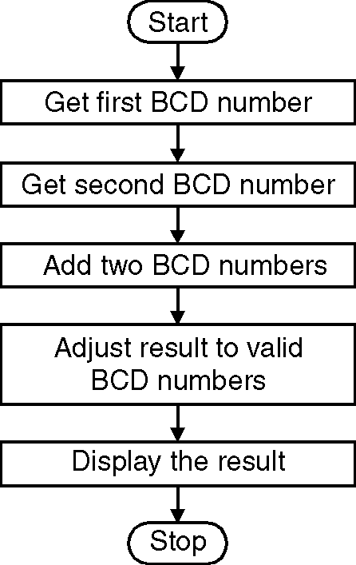

**Code**:

.model small

.data

a db 09H

b db 02H

.code

mov ax, @data ; Initialize data section

mov ds, ax

mov al, a ; Load number1 in al

mov bl, b ; Load number2 in bl

add al, bl ; Add numbers and result in al

daa ; Adjust result to valid BCD number

mov ch, 02h ; Count of digits to be displayed

mov cl, 04h ; Count to roll by 4 bits

mov bh, al ; Result in reg bh

l2: rol bh, cl ; Roll bl so that msb comes to lsb

mov dl, bh ; Load dl with data to be displayed

and dl, 0fH ; Get only lsb

cmp dl, 09 ; Check if digit is 0-9 or letter A-F

jbe l4

add dl, 07 ; If letter add 37H else only add 30H

l4: add dl, 30H

mov ah, 02 ; Function 2 under INT 21H (Display character)

int 21H

dec ch ; Decrement Count

jnz l2

mov ah, 4cH ; Terminate Program

int 21H

end

**Output**:

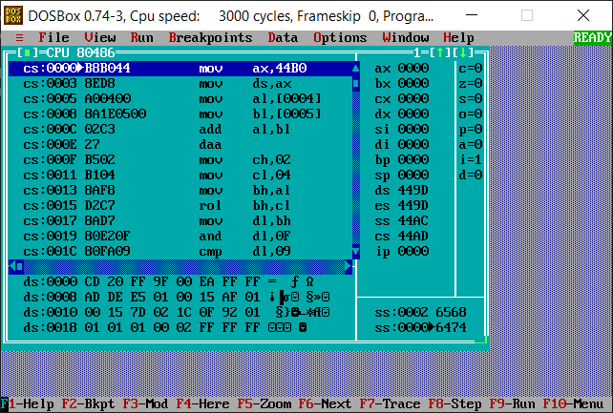

**Conclusion**: Thus, we have studied and understood the program to perform BCD addition of two numbers.